UNITED STATES

SECURITIES AND EXCHANGE COMMISSION

Washington, D.C. 20549

FORM 6-K

REPORT OF FOREIGN PRIVATE ISSUER

PURSUANT TO RULE 13a-16 OR 15d-16 UNDER THE

SECURITIES EXCHANGE ACT OF 1934

For the month of November 2026

Commission File Number: 000-30666

NETEASE, INC.

Room 802, 8/F, China Life Centre

Tower A, One HarbourGate

No. 18 Hung Luen Road

Kowloon, Hong Kong

People’s Republic of China

(Address of principal executive offices)

Indicate by check mark whether the registrant files or will file annual reports under cover of Form 20-F or Form 40-F.

Form 20-F ☒ Form 40-F ☐

EXPLANATORY NOTE

We submitted with The Stock Exchange of Hong Kong Limited the next day disclosure return forms dated October 28, 2026, October 29, 2026, October 30, 2026 and November 2, 2026 in relation to the movements in our authorized issued shares or treasury shares as a result of or in connection with certain events, attached as Exhibit 99.1, Exhibit 99.2, Exhibit 99.3 and Exhibit 99.4 to this current report on Form 6-K.

 |  | EXHIBIT INDEX
Exhibit 99.1 |  | Next Day Disclosure Return with The Stock Exchange of Hong Kong Limited – Next Day Disclosure Return dated October 28, 2026
Exhibit 99.2 |  | Next Day Disclosure Return with The Stock Exchange of Hong Kong Limited – Next Day Disclosure Return dated October 29, 2026
Exhibit 99.3 |  | Next Day Disclosure Return with The Stock Exchange of Hong Kong Limited – Next Day Disclosure Return dated October 30, 2026
Exhibit 99.4 |  | Next Day Disclosure Return with The Stock Exchange of Hong Kong Limited – Next Day Disclosure Return dated November 2, 2026

SIGNATURE

Pursuant to the requirements of the Securities Exchange Act of 1934, the registrant has duly caused this report to be signed on its behalf by the undersigned, thereunto duly authorized.

NETEASE, INC.

By | : /s/ William Lei Ding
Name | : | William Lei Ding
Title | : Chief Executive Officer

Date: November 2, 2026

Exhibit 99.1
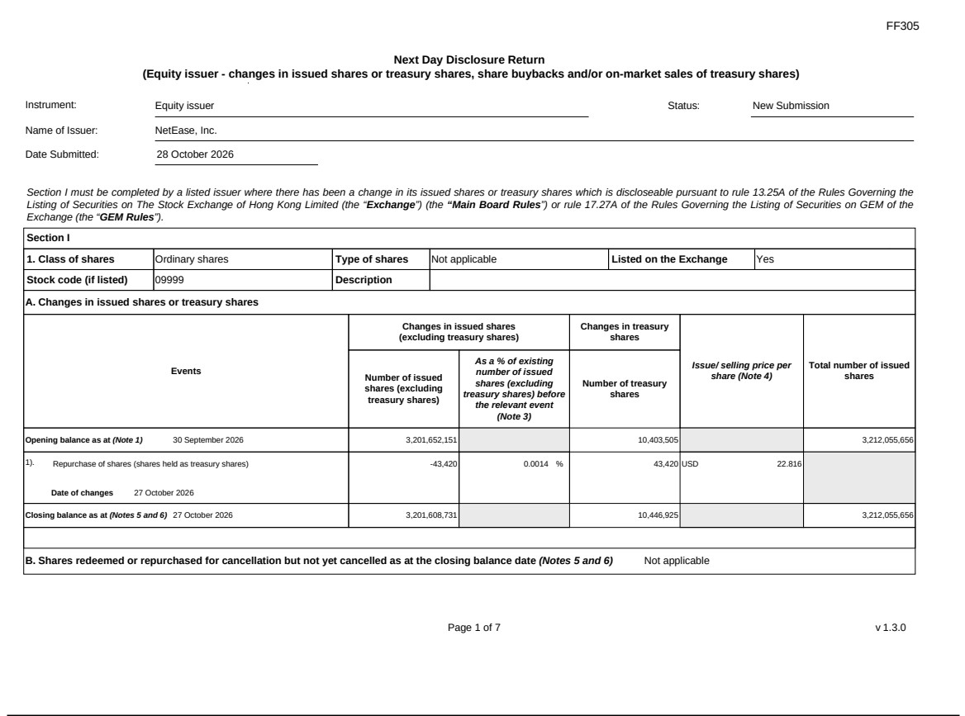

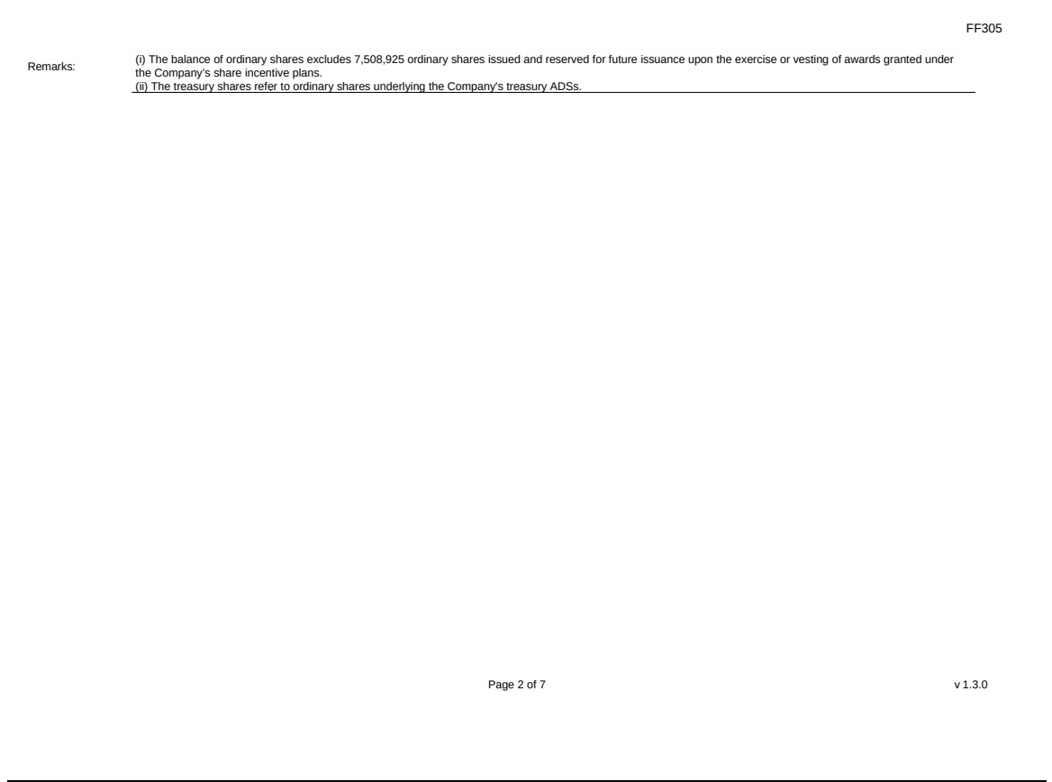

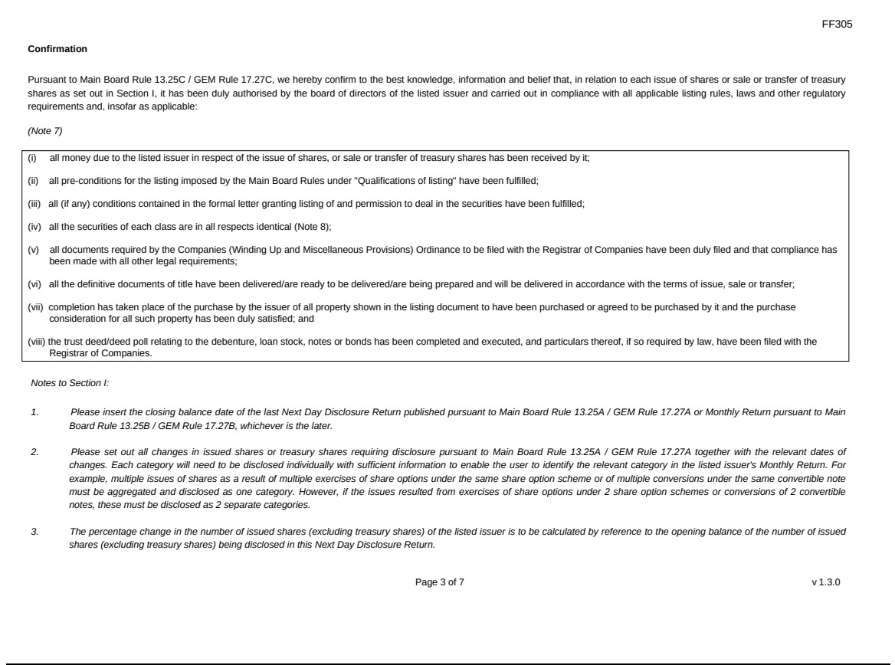

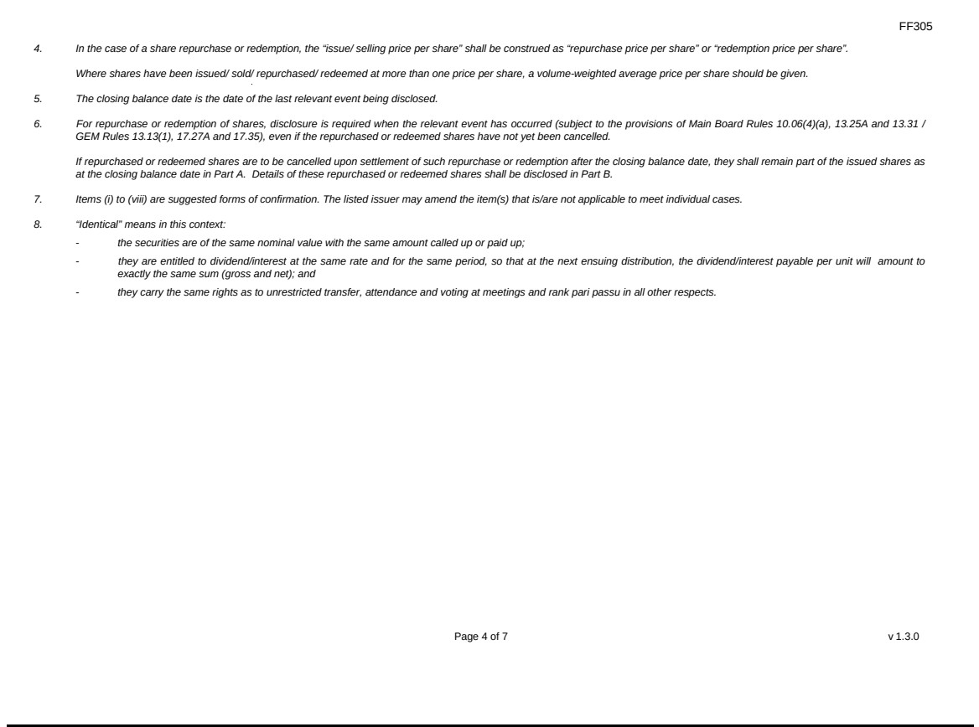

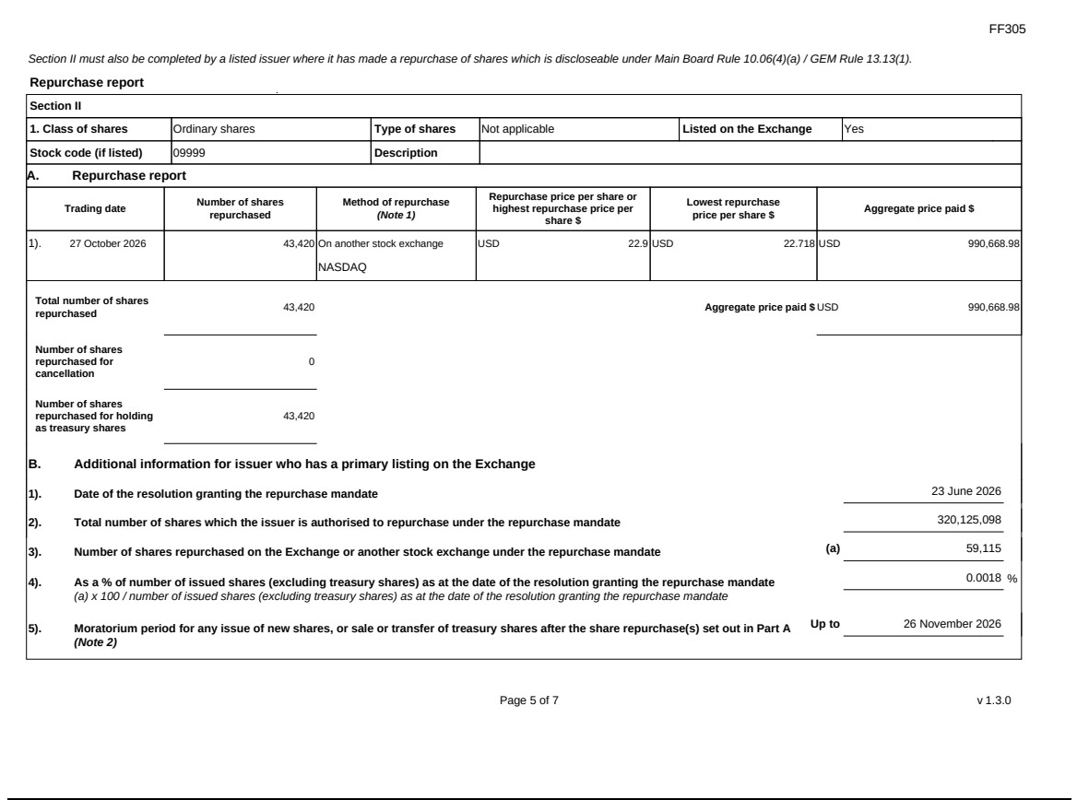

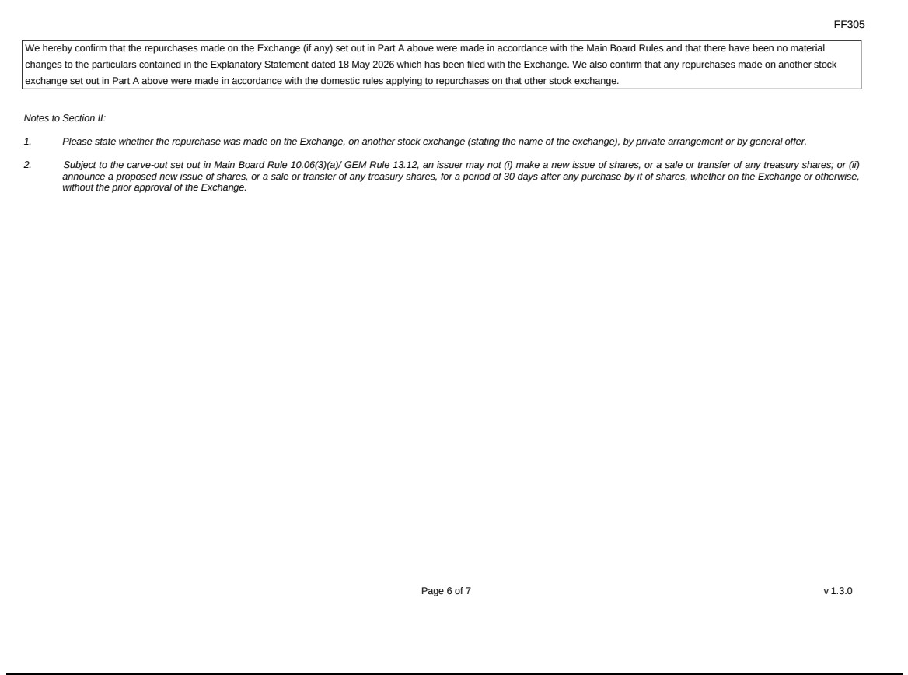

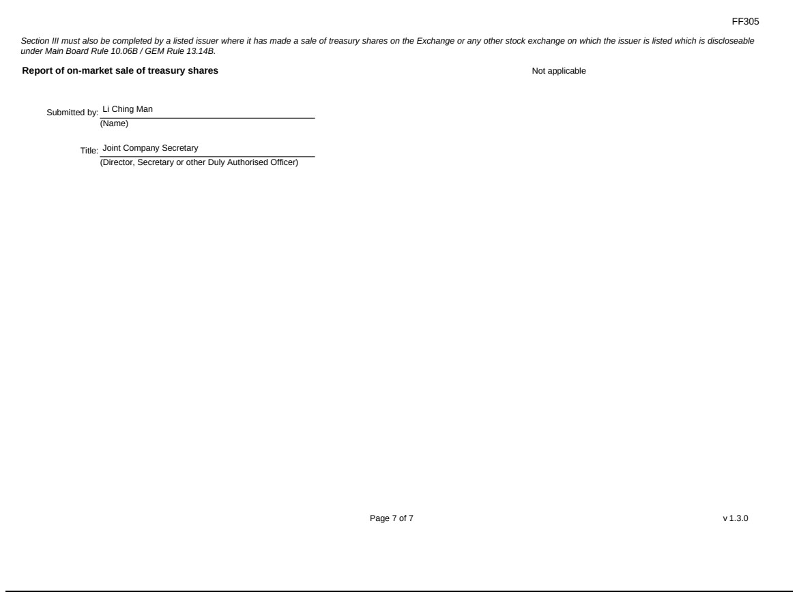

Exhibit 99.2
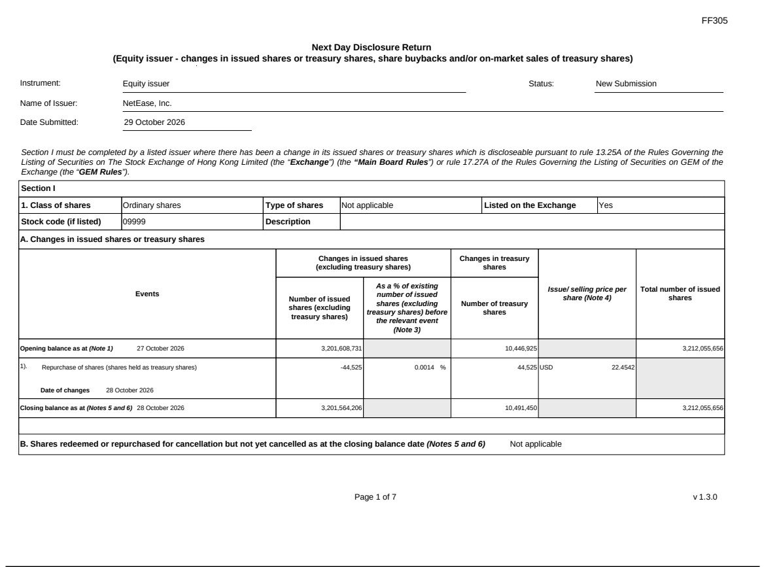

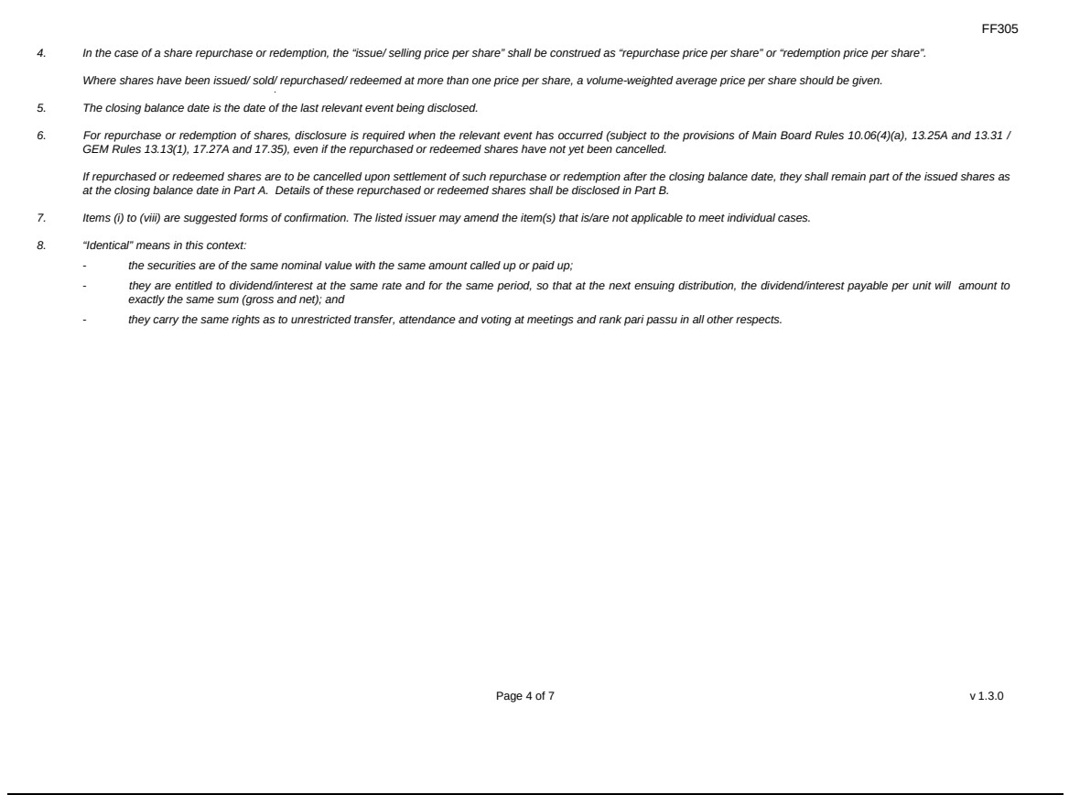

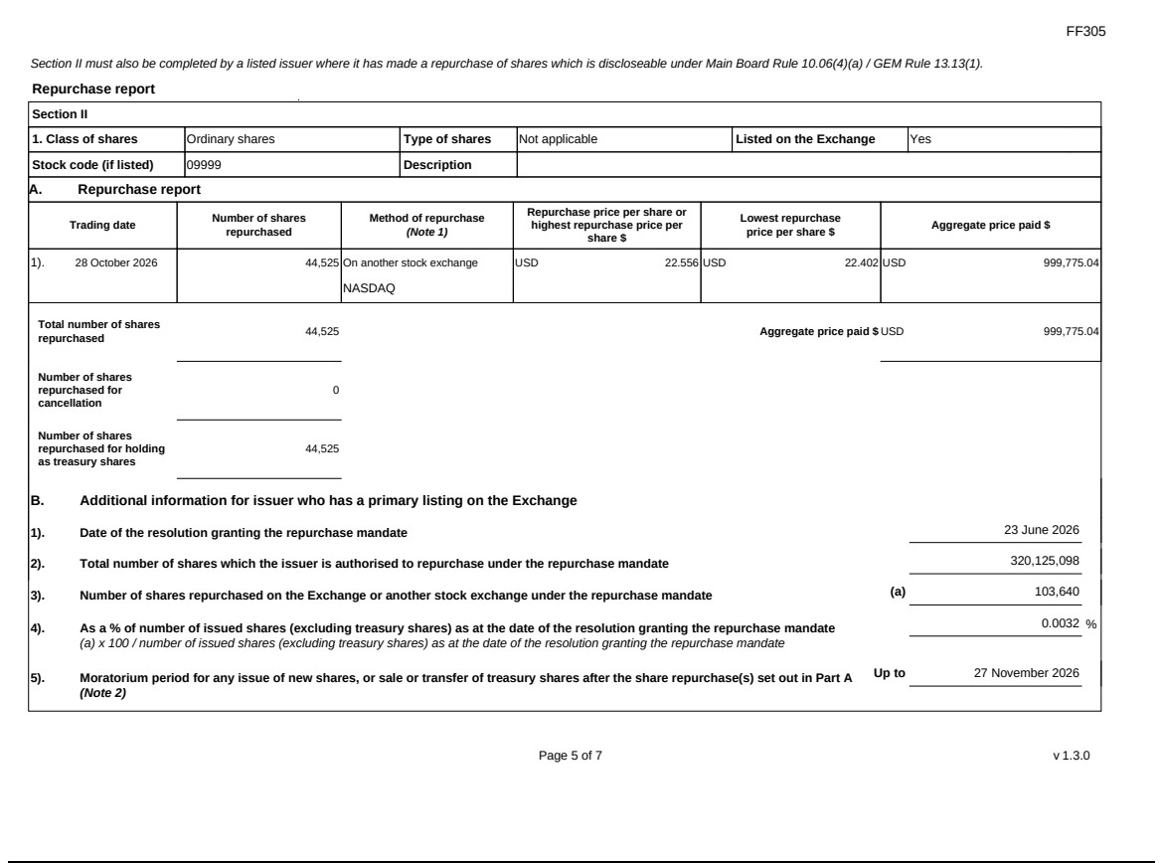

Exhibit 99.3
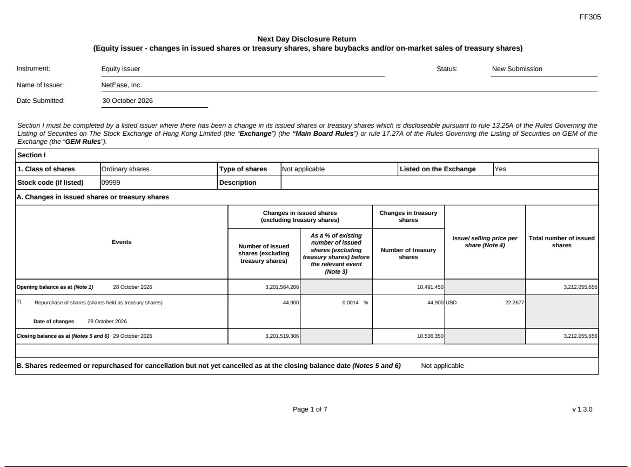

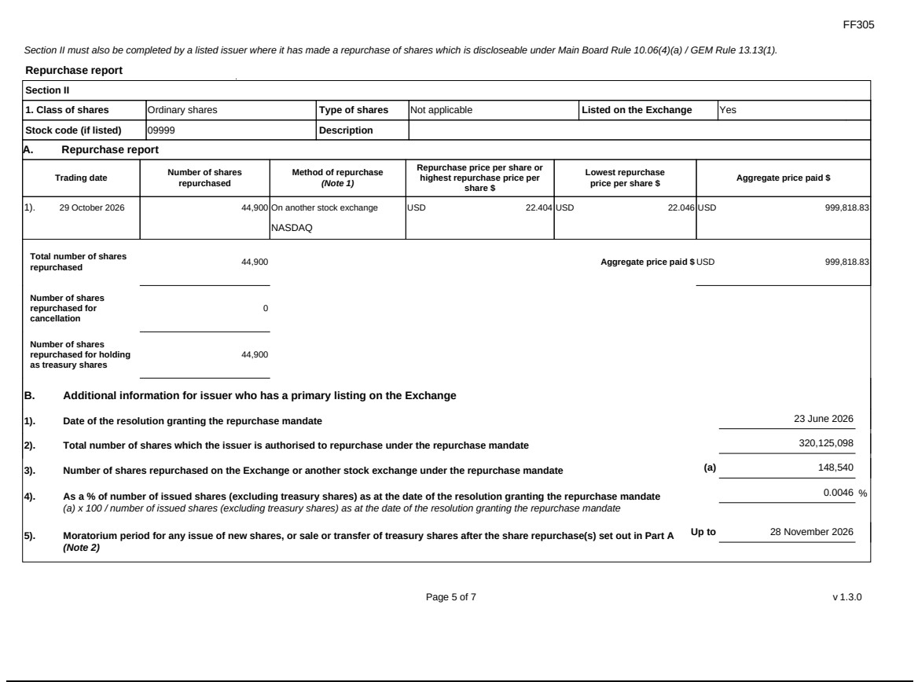

Exhibit 99.4


